How to run the Liri app

On the bash command line you will enter the command

Node nameofApp argument[2] “argument[3]” where argument 3 is in quotes for a string of artist or movie

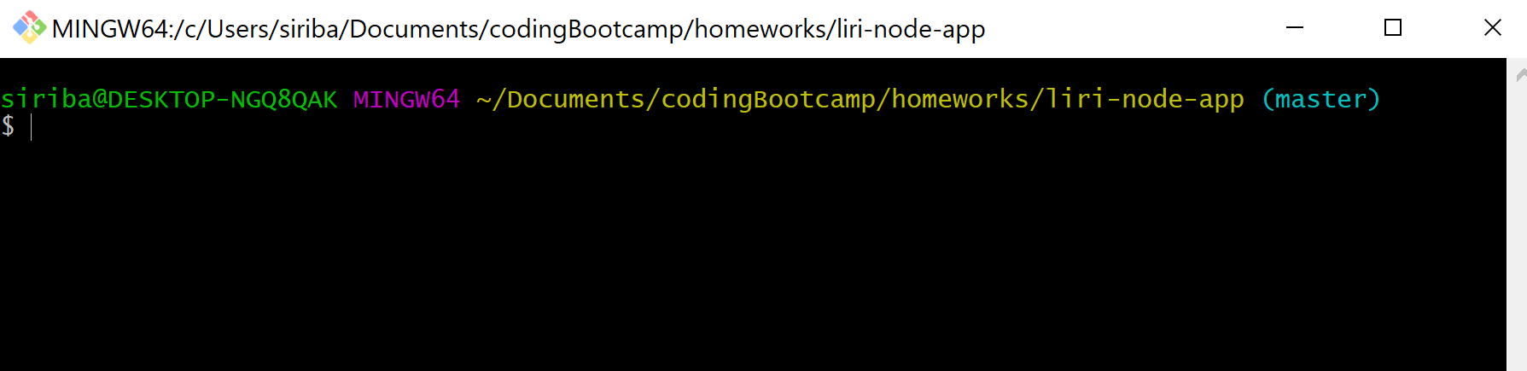



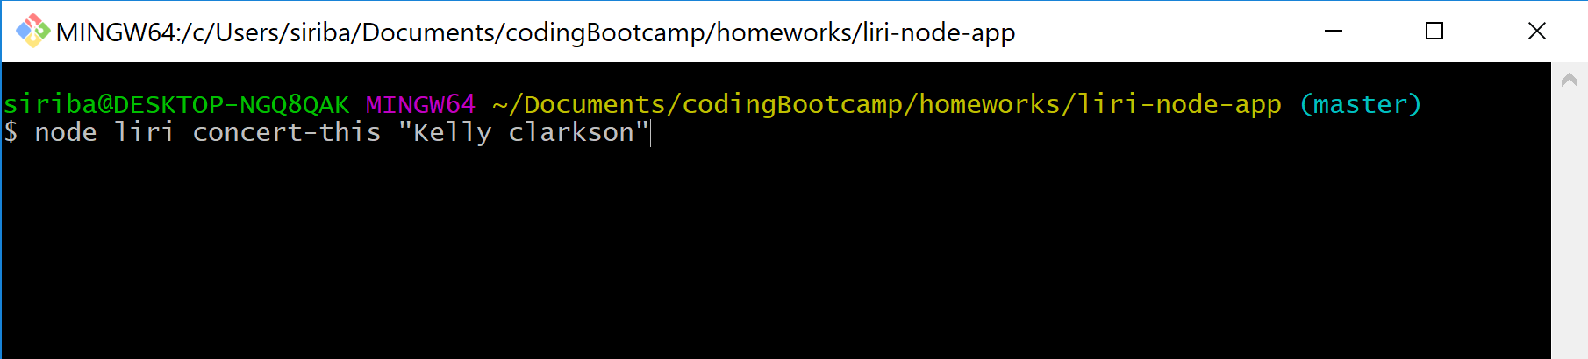

Concert-this will search bands in town api for concerts by the artist in argument 3 in our example Kelly Clarkson and enter

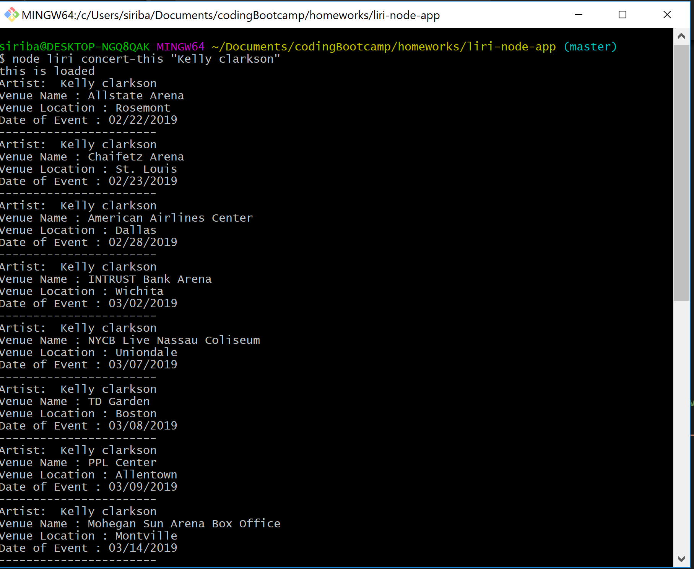

Do the above process for entering same command for movie or music

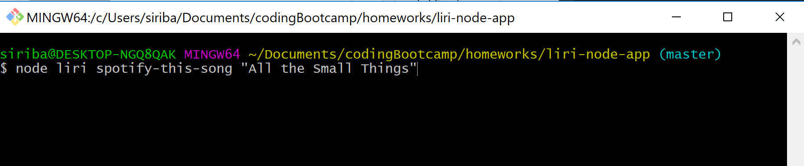

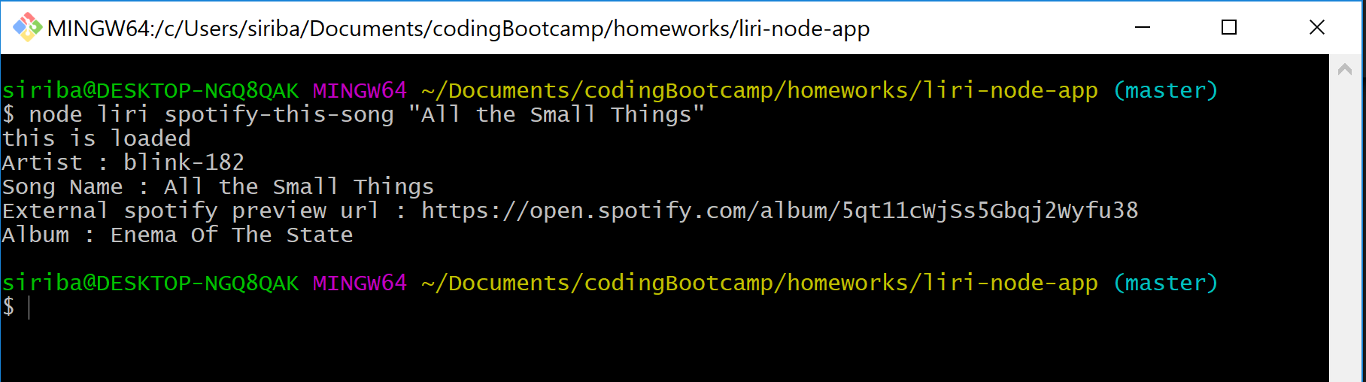

The music API will display artist, song title , spotify url and the album.